**Spatial and Temporal Dynamics of Conflict and Trade: A Computational Framework for Borderland Analysis at the Kenya-Uganda Frontier**

By Moneera Yassien

## **Abstract**

Borderland dynamics have traditionally been explored through qualitative, context-specific methods, yielding rich yet fragmented insights into their economic, social, and conflict-related dimensions. This study presents a computational framework that advances border studies by integrating spatial, temporal, and relational analyses, operationalized through two key indices: the Market Potential Index (MPI) and the Conflict Exposure Index (CI). The MPI quantifies trade accessibility by evaluating population distribution, infrastructure networks, and geographic distance, while the CI assesses conflict disruptions based on severity, frequency, and proximity to economic corridors. This integrated approach bridges traditionally isolated analyses to provide a comprehensive understanding of borderland dynamics. Using the Kenya-Uganda border as a case study, the framework reveals critical patterns, such as the dual challenges faced by high-MPI regions like Busia and Malaba, which exhibit strong economic potential alongside significant conflict exposure. In contrast, northern regions like Karamoja and Turkana illustrate the interplay of low economic accessibility and persistent conflict, driven by resource competition and climatic stressors. The framework also highlights the role of cultural networks in sustaining trade and mitigating conflict in the southern borderlands, emphasizing the importance of relational dynamics. To ensure reproducibility and adaptability, the study provides a Git repository containing detailed documentation, scripts, and datasets. This promotes transparency and allows researchers and policymakers to replicate the analysis, adapt the framework to other regions, or incorporate additional data. The findings underscore the framework’s utility in supporting evidence-based policymaking, offering actionable insights for designing conflict-sensitive infrastructure, fostering regional economic integration, and addressing the complexities of cross-border interactions.

# Introduction

Traditional border studies have largely relied on qualitative assessments and isolated case studies, providing valuable but fragmented insights into how borders operate as zones of economic exchange, conflict, and social interaction. This perspective is evident in the evolution of border studies, which has transitioned from viewing borders merely as territorial demarcations to understanding them as dynamic, multifaceted systems shaped by human, cultural, and economic interactions. The renaissance of border studies during the past decade has been characterized by a crossing of disciplinary borders, bringing together geographers, political scientists, sociologists, anthropologists, historians, literary scholars, legal experts, along with border practitioners engaged in the practical aspects of boundary demarcation, delimitation, and management (Kolossov & Scott, 2013).

While interdisciplinary efforts have enriched border studies, the predominance of qualitative, context-specific research has limited broader generalizations and the development of cohesive analytical frameworks (Hagen & Kawakubo, 2015). This emphasis on qualitative methods has often resulted in underdeveloped quantitative approaches, restricting our ability to capture the dynamic spatiotemporal realities of border regions. For example, the cascading effects of conflict on trade and the role of social networks in fostering economic resilience remain difficult to systematically quantify (Rodrigue et al., 2016; Massey, 2005). To address these challenges, this study proposes a computational framework that integrates spatial interaction theory and conflict studies to develop two indices: the Market Potential Index (MPI) and the Conflict Exposure Index (CI). These indices offer a scalable, data-driven approach for analyzing the economic and security landscapes of border regions.

The MPI quantifies trade accessibility by integrating data on population distribution, infrastructure networks, and geographic distance, while the CI measures conflict-related disruptions by assessing the severity, frequency, and proximity of conflict events to key economic corridors. This index system offers a systematic, scalable approach for quantifying the economic and security landscapes of border regions, in an attempt to contribute to advancing quantitative methods in the field.

The study builds on the foundational work of Eberhard-Ruiz (2024), who applied a Market Potential approach to measure armed conflict exposure at the border-post level. Their analysis focused on whether variations in conflict exposure along the Uganda-DRC border influenced regional exports to the DRC. While valuable, it primarily analyzed static relationships between conflict and trade potential. To build on this piece of knowledge, this paper introduces a computational framework that incorporates spatial and temporal dimensions, enabling a more comprehensive analysis of border dynamics across diverse geopolitical regions. Refining these indices and embedding them in a layered analytical structure makes the computational framework replicable and adaptable for assessing border dynamics across diverse geopolitical contexts.

The framework draws on spatial interaction theory, New Economic Geography (Krugman, 1998), and conflict studies to quantify spatial interaction and market potential in border regions, assess conflict exposure's temporal impact on cross-border economic activities, and integrate these analyses into a comprehensive understanding of borderland dynamics. Its analytical structure operates across three levels: (1) a spatial layer that examines how infrastructure, distance, and market size influence economic interactions through the MPI; (2) a temporal layer that analyzes conflict evolution and trade disruption using the CI; and (3) a relational layer that aims to integrate social networks and informal trade dynamics in future research (Massey, 2005). By operationalizing theoretical concepts into measurable indices and combining GIS-based mapping with economic and conflict analysis, the framework offers replicability across diverse geopolitical contexts and supports both research and policy applications.

The Kenya-Uganda border serves as a case study to validate the framework’s ability to analyze the interplay between market accessibility and conflict exposure. With approximately 23,000 people crossing daily at 60 points along an 85-kilometer stretch (Lamarque & Brown, 2022), this borderland illustrates the dual pressures of economic opportunity and security risks. The region is characterized by protracted, localized conflicts that, while not escalating into large-scale wars, significantly disrupt trade and social stability. By applying the MPI and CI, the framework captures these dynamics, offering insights into the region's economic connectivity and vulnerability to persistent insecurity.

This paper is structured to provide a comprehensive analysis of the proposed computational framework. It begins with a review of relevant literature on spatial interaction theory, conflict studies, and quantitative approaches to border analysis, identifying key methodological linkages. The methodology section details the construction of the MPI and CI, including data sources, analytical procedures, and validation strategies. This is followed by an application of the framework to the Kenya-Uganda border, presenting key findings and insights. The discussion examines the framework’s methodological implications, strengths, and limitations, while the conclusion summarizes the study’s contributions and outlines future research directions, particularly the integration of relational dynamics.

## **Methodology: A Computational Framework for Analyzing Border Dynamics**

This section outlines the design and operationalization of the proposed computational framework for analyzing the spatial and temporal dynamics of border regions. The framework is specifically developed to measure two critical dimensions of borderland dynamics: economic accessibility and conflict exposure. It begins by establishing the theoretical foundation for the Market Potential Index (MPI) and Conflict Exposure Index (CI), followed by the construction of these indices using spatial interaction and conflict theories. The methods are designed for adaptability, enabling the framework to be applied to other border regions with similar dynamics.

### 3.1. Step 1: Theoretical Foundation - Borders as Dynamic Systems

We begin with a foundational understanding that borders are not static demarcations but dynamic systems where space, time, and social relations converge. This framework builds on three interconnected theoretical perspectives to capture this complexity: spatial interaction theory, Protracted Social Conflict theory, and relational space concepts.

#### 3.1.1. Spatial Level: Infrastructure and Economic Geography

Spatial interaction theory (Roy and Thill, 2004) provides a theoretical basis for understanding how economic activities flow between locations. The theory posits that spatial interactions, like trade flows, follow principles similar to gravitational force: they are proportional to the economic "mass" of locations and inversely proportional to the distance between them. This theoretical foundation structures the MPI through three key components:

First, the theory emphasizes location characteristics through its gravity model foundation, where interaction is driven by the "mass" of locations (measured through population size and economic activity). In the southern Uganda-Kenya borderlands, this gravitational pull is evident in how twin towns Busia, Malaba, and Lwakhakha function as economic anchors, channeling commercial traffic between Kenya, Uganda, Rwanda, South Sudan, and the DRC (Lamarque and Bown, 2022).

Second, the theory's concept of transferability, which concerns the ease and cost of movement, is operationalized through infrastructure networks. Infrastructure investments have transformed Busia and Malaba into vital trade hubs, with the Northern Corridor's transportation network reducing movement costs through improved road and rail infrastructure (Van Hoestenberghe, Roelfsema and Khalidi, 2016).

Third, the theory's distance decay principle, which explains how interactions diminish over space, is captured through decay parameters. Klaesson et al. (2016) demonstrate how these effects vary across economic sectors, with knowledge-intensive services showing stronger distance sensitivity (Johansson & Klaesson, 2017). This is empirically supported in our study area, where connected markets like Malaba show 30% higher trade volumes than remote areas like Kaabong. To address sectoral data gaps, our framework employs sensitivity analysis testing different decay values (0.02, 0.03, 0.05) against observed trade patterns.

While these spatial interaction components establish a foundation for understanding border dynamics, the theory's limitations necessitate a broader analytical scope. Critics highlight that focusing solely on distance and size oversimplifies the complex reality of borderland interactions, particularly in conflict-prone regions. The theory's neglect of non-spatial factors like political instability and historical tensions is especially relevant in areas where security conditions can override geographic advantages. This limitation points to the need for a temporal dimension that captures how conflict patterns evolve and influence economic interactions over time. which we explore in the next section.

3.1.2. Temporal Level: Conflict Dynamics and Evolution

The temporal dimension of borderland conflicts demands a computational framework that can capture both their persistent nature and evolving dynamics. Protracted Social Conflict theory (PSC) (Azar, 1990) illuminates how conflicts become deeply embedded in social systems through multiple reinforcing mechanisms. Rather than viewing conflicts as episodic disruptions, PSC theory reveals their structural nature, particularly in regions where identity-based divisions intersect with resource competition and institutional weaknesses. embed insecurity in border regions through unmet needs, governance failures, and resource competition.The Kenya-Uganda borderlands exemplify these dynamics. In the Arid and Semi-Arid Lands (ASALs), environmental pressures transform what might appear as isolated incidents into self-sustaining conflict cycles. When droughts shrink pastoral corridors, the resulting competition for water and grazing lands triggers livestock raiding. These raids initiate retaliatory cycles that progressively weaken traditional conflict resolution mechanisms and embed insecurity into the borderland's social fabric (Matiko & Hamasi, 2022). PSC theory's emphasis on feedback loops helps explain how these localized conflicts ripple through economic systems. Cattle raids near trade routes to Busia illustrate this cascade effect: beyond immediate livestock losses, they elevate transport costs and deter investment, creating compound impacts on regional trade. To capture these complex dynamics, the Conflict Exposure Index (CI) employs a weighted system that considers both event severity and location. A raid near major trade routes, for instance, would carry a higher weight to reflect its broader economic ramifications.

The CI's methodology ensures robust conflict analysis by drawing from ACLED's conflict event database, the index aggregates incidents while weighting them by both severity and proximity to economic corridors. This cumulative measurement approach aligns with PSC theory's understanding of how conflicts become self-reinforcing through repeated disruptions and institutional embedding. The resulting index provides a quantitative measure of how conflict exposure accumulates and persists across the borderland space over time.

### 3.1.3. Linking Spatial and Temporal Levels to the Relational Level: Social Networks and Cultural Connections

Spatial interaction theory and Protracted Social Conflict theory provide essential foundations for understanding borderland dynamics, but a relational perspective adds critical insight into the cultural and human dimensions specific to certain regions. Drawing on Massey’s (2005) concept of relational space, this study views borders as areas shaped by localized social relations, histories, and power structures.

At the Kenya-Uganda border, social and economic networks adapt to unique local conditions, despite the colonial borders that divide communities. For instance, the Luhya people's kinship ties and cross-border economic activities persist, with informal trade networks evolving in response to infrastructure constraints and conflict dynamics (Ndalilah & Atozo, 2024).

Shared linguistic spaces also play a significant role in enabling cross-border interactions in this region. The use of Kiswahili, Dholuo, and Luhya languages creates "mutual intelligibility zones" that facilitate trust, trade, and navigation of regulatory differences. Communities such as Busia specifically benefit from these connections, maintaining trade relationships even amidst challenges posed by informal economic zones (Odhiambo et al., 2022). These examples underscore the relevance of relational dynamics in complementing spatial and temporal analyses within this specific borderland context.

Beyond fostering economic interactions, these relational dynamics contribute to conflict mitigation and resilience. For example, customary conflict resolution mechanisms embedded within these communities often leverage shared histories and kinship ties to de-escalate tensions and maintain stability in the face of persistent insecurity. In areas such as Busia and Malaba, these social connections act as informal safety nets, enabling communities to weather economic and security challenges. While the MPI and CI capture the spatial and temporal dimensions of borderland dynamics, the relational layer reveals how these human and cultural factors interact with economic potential and conflict exposure, often mediating or amplifying their effects.

This section constructs the computational framework into three quantifiable components: the Market Potential Index (MPI), the Conflict Exposure Index (CI), and relational analysis. The MPI captures how distance, infrastructure, and population density influence economic activities, while the CI quantifies conflict dynamics using Protracted Social Conflict theory. The relational analysis integrates socio-cultural networks, emphasizing the role of linguistic and kinship ties in shaping trade and conflict at the Kenya-Uganda border. Together, these components provide a structured framework for analyzing borderland dynamics.

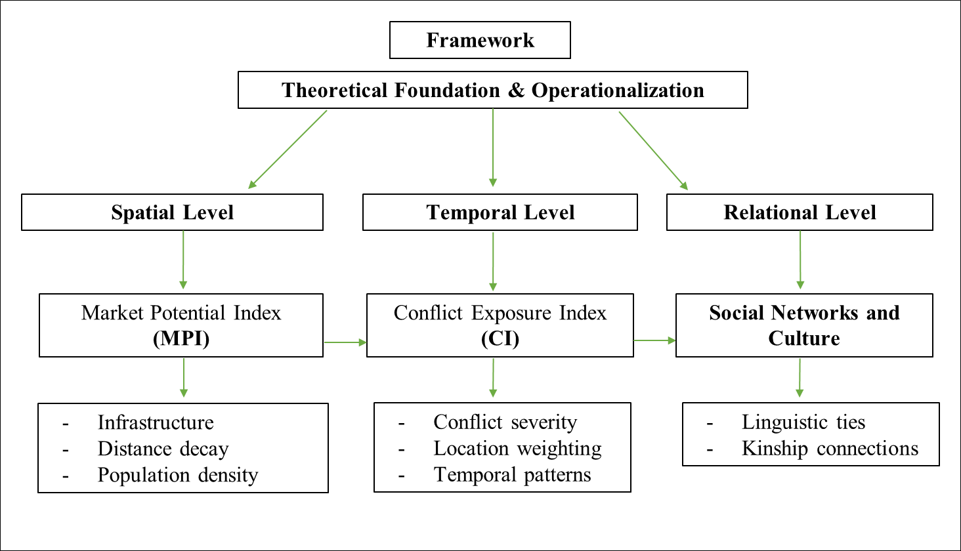

## 3.2. Step 2: Operationalization of Theoretical Concepts

Building on the theoretical foundations outlined earlier, this section presents the operationalization of these theories into a quantitative framework. The framework analyzes the spatial, temporal, and relational dynamics of border regions by focusing on two critical dimensions: economic accessibility and conflict exposure. These dimensions are captured through the Market Potential Index (MPI) and Conflict Exposure Index (CI), which translate theoretical concepts into measurable indices. By integrating these indices, the framework examines the interplay between infrastructure, trade, and conflict in cross-border contexts. Designed for adaptability, the methodology offers a structured approach that can be applied to regions with similar geopolitical and economic characteristics. The Kenya-Uganda border serves as a case study to validate this framework, demonstrating its utility in capturing the complex dynamics of trade and conflict.

**Layer 1: Spatial Level**

The MPI quantifies how geographic factors such as distance, infrastructure, and population influence trade accessibility. Leveraging high-resolution datasets from WorldPop and OpenStreetMap, the analysis accounts for varying accessibility scenarios through conditional buffering for urban and rural dynamics. By integrating distance-decay effects and sensitivity analyses the MPI provides insights into how infrastructure investments and geographic connectivity shape economic flows.

#### **Data Sources and Structure**

The MPI calculation relies on a high-resolution dataset containing critical variables:

1. **Population**: Represents the total population of each market, serving as a proxy for potential economic demand.
2. **Route Length:** Measures the distance between markets and their respective border posts. This variable, recorded in meters, was converted to kilometers to align with the exponential decay function’s scale.
3. **Market and Border Post Identifiers:** Unique identifiers link each market to its corresponding border post, facilitating pairwise analysis of economic potential.
4. **Market size:** Measured by buffers approach for markets based on their type, 1.5 km for urban and 3 km for non-urban markets, to enhance the spatial granularity.

The dataset integrates population estimates from WorldPop and road network data, including route lengths, derived from OpenStreetMap (OSM).

**Mathematical Framework**

The MPI calculation employs the following formula:

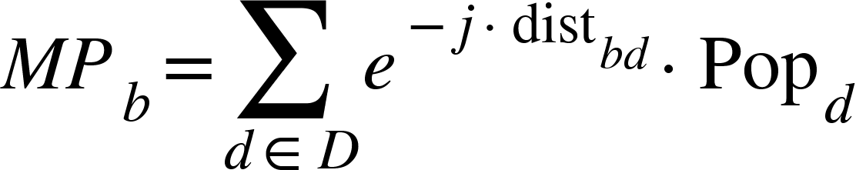

{"mathml":"<math style=\"font-family:stix;font-size:16px;\" xmlns=\"http://www.w3.org/1998/Math/MathML\"><mstyle mathsize=\"16px\"><mi>M</mi><mi>P</mi><mo>&#xA0;</mo><mo>&#xA0;</mo><mi>b</mi><mo>&#xA0;</mo><mo>&#x200B;</mo><mo>&#xA0;</mo><mo>&#xA0;</mo><mo>:</mo><mo>&#xA0;</mo><mi>M</mi><mi>a</mi><mi>r</mi><mi>k</mi><mi>e</mi><mi>t</mi><mo>&#xA0;</mo><mi>P</mi><mi>o</mi><mi>t</mi><mi>e</mi><mi>n</mi><mi>t</mi><mi>i</mi><mi>a</mi><mi>l</mi><mo>&#xA0;</mo><mi>f</mi><mi>o</mi><mi>r</mi><mo>&#xA0;</mo><mi>a</mi><mo>&#xA0;</mo><mi>s</mi><mi>p</mi><mi>e</mi><mi>c</mi><mi>i</mi><mi>f</mi><mi>i</mi><mi>c</mi><mo>&#xA0;</mo><mi>b</mi><mi>o</mi><mi>r</mi><mi>d</mi><mi>e</mi><mi>r</mi><mo>&#xA0;</mo><mi>p</mi><mi>o</mi><mi>s</mi><mi>t</mi><mo>&#xA0;</mo><mo>(</mo><mo>&#x1D44F;</mo><mo>)</mo><mo>.</mo><mspace linebreak=\"newline\"/><msup><mo>&#x1D452;</mo><mrow><mo>&#x2212;</mo><mo>&#x1D457;</mo><mo>.</mo><mi>d</mi><mi>i</mi><mi>s</mi><mi>t</mi><mo>&#xA0;</mo><mi>b</mi><mi>d</mi><mo>&#xA0;</mo></mrow></msup><mo>:</mo><mo>&#xA0;</mo><mi>A</mi><mi>n</mi><mo>&#xA0;</mo><mi>e</mi><mi>x</mi><mi>p</mi><mi>o</mi><mi>n</mi><mi>e</mi><mi>n</mi><mi>t</mi><mi>i</mi><mi>a</mi><mi>l</mi><mo>&#xA0;</mo><mi>d</mi><mi>e</mi><mi>c</mi><mi>a</mi><mi>y</mi><mo>&#xA0;</mo><mi>f</mi><mi>u</mi><mi>n</mi><mi>c</mi><mi>t</mi><mi>i</mi><mi>o</mi><mi>n</mi><mo>&#xA0;</mo><mi>t</mi><mi>h</mi><mi>a</mi><mi>t</mi><mo>&#xA0;</mo><mi>m</mi><mi>o</mi><mi>d</mi><mi>e</mi><mi>l</mi><mi>s</mi><mo>&#xA0;</mo><mi>t</mi><mi>h</mi><mi>e</mi><mo>&#xA0;</mo><mi>d</mi><mi>i</mi><mi>m</mi><mi>i</mi><mi>n</mi><mi>i</mi><mi>s</mi><mi>h</mi><mi>i</mi><mi>n</mi><mi>g</mi><mo>&#xA0;</mo><mi>e</mi><mi>f</mi><mi>f</mi><mi>e</mi><mi>c</mi><mi>t</mi><mo>&#xA0;</mo><mi>o</mi><mi>f</mi><mo>&#xA0;</mo><mi>d</mi><mi>i</mi><mi>s</mi><mi>tan</mi><mi>c</mi><mi>e</mi><mo>&#xA0;</mo><mi>o</mi><mi>n</mi><mo>&#xA0;</mo><mi>t</mi><mi>r</mi><mi>a</mi><mi>d</mi><mi>e</mi><mo>&#xA0;</mo><mi>p</mi><mi>o</mi><mi>t</mi><mi>e</mi><mi>n</mi><mi>t</mi><mi>i</mi><mi>a</mi><mi>l</mi><mo>.</mo><mspace linebreak=\"newline\"/><msub><mrow><mi>P</mi><mi>o</mi><mi>p</mi><mo>&#xA0;</mo></mrow><mrow><mi>d</mi><mo>&#xA0;</mo></mrow></msub><mo>&#xA0;</mo><mo>&#xA0;</mo><mo>:</mo><mo>&#xA0;</mo><mi>P</mi><mi>o</mi><mi>p</mi><mi>u</mi><mi>l</mi><mi>a</mi><mi>t</mi><mi>i</mi><mi>o</mi><mi>n</mi><mo>&#xA0;</mo><mi>o</mi><mi>f</mi><mo>&#xA0;</mo><mi>t</mi><mi>h</mi><mi>e</mi><mo>&#xA0;</mo><mi>m</mi><mi>a</mi><mi>r</mi><mi>k</mi><mi>e</mi><mi>t</mi><mo>&#xA0;</mo><mo>(</mo><mo>&#x1D451;</mo><mo>)</mo><mo>.</mo><mspace linebreak=\"newline\"/><mi>j</mi><mo>:</mo><mo>&#xA0;</mo><mi>D</mi><mi>e</mi><mi>c</mi><mi>a</mi><mi>y</mi><mo>&#xA0;</mo><mi>p</mi><mi>a</mi><mi>r</mi><mi>a</mi><mi>m</mi><mi>e</mi><mi>t</mi><mi>e</mi><mi>r</mi><mo>,</mo><mo>&#xA0;</mo><mi>v</mi><mi>a</mi><mi>r</mi><mi>y</mi><mi>i</mi><mi>n</mi><mi>g</mi><mo>&#xA0;</mo><mi>t</mi><mi>o</mi><mo>&#xA0;</mo><mi>c</mi><mi>a</mi><mi>p</mi><mi>t</mi><mi>u</mi><mi>r</mi><mi>e</mi><mo>&#xA0;</mo><mi>d</mi><mi>i</mi><mi>f</mi><mi>f</mi><mi>e</mi><mi>r</mi><mi>e</mi><mi>n</mi><mi>t</mi><mo>&#xA0;</mo><mi>s</mi><mi>e</mi><mi>n</mi><mi>s</mi><mi>i</mi><mi>t</mi><mi>i</mi><mi>v</mi><mi>i</mi><mi>t</mi><mi>i</mi><mi>e</mi><mi>s</mi><mo>&#xA0;</mo><mi>t</mi><mi>o</mi><mo>&#xA0;</mo><mi>d</mi><mi>i</mi><mi>s</mi><mi>tan</mi><mi>c</mi><mi>e</mi><mo>.</mo><mspace linebreak=\"newline\"/></mstyle></math>","truncated":false}

Three predefined decay parameters (j=0.02,0.03,0.05) reflect varying levels of distance elasticity. These parameters enable the analysis to capture both broad and localized economic impacts, aligning with Fotheringham’s (1982) principles of distance decay.

1. Low Decay (j=0.02): Captures long-range economic interactions with minimal decay.
2. Medium Decay (j=0.03): Balances short- and long-range economic effects.
3. High Decay (j=0.05): Models localized economic potential with steep decay over distance

**Layer 2: Temporal Level**

The CI quantifies the impact of conflict events on economic activities by integrating both their severity and proximity to trade routes. Events such as cattle raids or resource disputes, which are prevalent in regions like the Kenya-Uganda borderlands, directly disrupt trade and elevate transport costs. The CI incorporates the temporal variability of conflict by accounting for cyclical patterns and feedback loops, where recurrent incidents reinforce instability and economic disruption. For instance, conflict events occurring near major trade hubs like Busia or Malaba should have higher weights to reflect their amplified impact on trade flows.

**Conflict Event Data**: The dataset includes counts of conflict events and fatalities recorded annually. These variables provide a quantitative measure of conflict severity and its spatial distribution across the Kenya-Uganda border. Conflict event counts serve as proxies for the frequency of disruptions, while fatalities indicate the severity of each event (Raleigh et al. 2010).

**Trade Route Data**: Route lengths between border posts and markets are used to calculate the proximity of conflicts to trade corridors. Distances, initially recorded in meters, were converted to kilometers for compatibility with the CI formula. Proximity serves as a key factor in determining the likelihood and magnitude of trade disruption.

**Market and Border Identifiers**: Unique identifiers for border posts and markets facilitate the aggregation of conflict impacts by location and time period, enabling both temporal trend analysis and spatial comparison.

**Geospatial Data**: The geographic coordinates (latitude and longitude) of border posts and markets are used to map conflict impacts and visualize the spatial distribution of CI values. This component enhances the interpretability of results by linking conflict events to specific locations.

### **Mathematical Framework**

The CI calculation employs the following formula:

{"mathml":"<math style=\"font-family:stix;font-size:16px;\" xmlns=\"http://www.w3.org/1998/Math/MathML\"><mstyle mathsize=\"16px\"><mi>C</mi><msub><mi>I</mi><mrow><mi>b</mi><mo>,</mo><mi>t</mi><mo>&#xA0;</mo><mo>&#xA0;</mo><mo>=</mo><mo>&#xA0;</mo><mo>&#xA0;</mo><mo>&#xA0;</mo></mrow></msub><munder><mrow><mo>&#x2211;</mo><mi>w</mi><msub><mo>&#xA0;</mo><mrow><mi>l</mi><mo>,</mo><mi>t</mi><mo>&#xA0;</mo><mo>&#x200B;</mo><mo>&#xA0;</mo><mo>&#xA0;</mo></mrow></msub><mo>.</mo><mo>&#xA0;</mo><msub><mi>c</mi><mrow><mi>l</mi><mo>,</mo><mi>t</mi><mo>&#xA0;</mo><mo>&#x200B;</mo></mrow></msub></mrow><mi>l</mi></munder><mspace linebreak=\"newline\"/><mspace linebreak=\"newline\"/><mi>C</mi><msub><mi>I</mi><mrow><mi>b</mi><mo>,</mo><mi>t</mi><mo>&#xA0;</mo><mo>&#xA0;</mo><mo>:</mo><mo>&#xA0;</mo></mrow></msub><mi>C</mi><mi>o</mi><mi>n</mi><mi>f</mi><mi>l</mi><mi>i</mi><mi>c</mi><mi>t</mi><mo>&#xA0;</mo><mi>E</mi><mi>x</mi><mi>p</mi><mi>o</mi><mi>s</mi><mi>u</mi><mi>r</mi><mi>e</mi><mo>&#xA0;</mo><mi>I</mi><mi>n</mi><mi>d</mi><mi>e</mi><mi>x</mi><mo>&#xA0;</mo><mi>f</mi><mi>o</mi><mi>r</mi><mo>&#xA0;</mo><mi>b</mi><mi>o</mi><mi>r</mi><mi>d</mi><mi>e</mi><mi>r</mi><mo>&#xA0;</mo><mi>p</mi><mi>o</mi><mi>s</mi><mi>t</mi><mo>&#xA0;</mo><mo>&#xA0;</mo><mo>&#x1D44F;</mo><mo>&#xA0;</mo><mi>a</mi><mi>t</mi><mo>&#xA0;</mo><mi>t</mi><mi>i</mi><mi>m</mi><mi>e</mi><mo>&#xA0;</mo><mo>&#xA0;</mo><mo>&#x1D461;</mo><mo>.</mo><mspace linebreak=\"newline\"/><mi>w</mi><msub><mo>&#xA0;</mo><mrow><mi>l</mi><mo>,</mo><mi>t</mi><mo>&#xA0;</mo><mo>&#x200B;</mo><mo>&#xA0;</mo><mo>&#xA0;</mo></mrow></msub><mo>:</mo><mo>&#xA0;</mo><mi>W</mi><mi>e</mi><mi>i</mi><mi>g</mi><mi>h</mi><mi>t</mi><mo>&#xA0;</mo><mi>f</mi><mi>o</mi><mi>r</mi><mo>&#xA0;</mo><mi>c</mi><mi>o</mi><mi>n</mi><mi>f</mi><mi>l</mi><mi>i</mi><mi>c</mi><mi>t</mi><mo>&#xA0;</mo><mi>e</mi><mi>v</mi><mi>e</mi><mi>n</mi><mi>t</mi><mo>&#xA0;</mo><mo>&#xA0;</mo><mo>&#x1D459;</mo><mo>&#xA0;</mo><mi>l</mi><mo>&#xA0;</mo><mi>a</mi><mi>t</mi><mo>&#xA0;</mo><mi>t</mi><mi>i</mi><mi>m</mi><mi>e</mi><mo>&#xA0;</mo><mo>&#xA0;</mo><mo>&#x1D461;</mo><mo>&#xA0;</mo><mi>t</mi><mo>,</mo><mo>&#xA0;</mo><mi>c</mi><mi>a</mi><mi>l</mi><mi>c</mi><mi>u</mi><mi>l</mi><mi>a</mi><mi>t</mi><mi>e</mi><mi>d</mi><mo>&#xA0;</mo><mi>a</mi><mi>s</mi><mo>&#xA0;</mo><mo>&#xA0;</mo><mi>f</mi><mi>a</mi><mi>t</mi><mi>a</mi><mi>l</mi><mi>i</mi><mi>t</mi><mi>i</mi><mi>e</mi><mi>s</mi><mo>&#xA0;</mo><mo>+</mo><mo>&#xA0;</mo><mn>0</mn><mo>.</mo><mn>5</mn><mo>.</mo><mspace linebreak=\"newline\"/><mspace linebreak=\"newline\"/><mo>&#xA0;</mo><msub><mi>c</mi><mrow><mi>l</mi><mo>,</mo><mi>t</mi><mo>&#xA0;</mo><mo>&#x200B;</mo></mrow></msub><mo>&#xA0;</mo><mo>:</mo><mo>&#xA0;</mo><mo>&#xA0;</mo><mi>P</mi><mi>r</mi><mi>o</mi><mi>x</mi><mi>i</mi><mi>m</mi><mi>i</mi><mi>t</mi><mi>y</mi><mo>&#xA0;</mo><mi>i</mi><mi>n</mi><mi>d</mi><mi>i</mi><mi>c</mi><mi>a</mi><mi>t</mi><mi>o</mi><mi>r</mi><mo>,</mo><mo>&#xA0;</mo><mi>i</mi><mi>n</mi><mi>v</mi><mi>e</mi><mi>r</mi><mi>s</mi><mi>e</mi><mi>l</mi><mi>y</mi><mo>&#xA0;</mo><mi>p</mi><mi>r</mi><mi>o</mi><mi>p</mi><mi>o</mi><mi>r</mi><mi>t</mi><mi>i</mi><mi>o</mi><mi>n</mi><mi>a</mi><mi>l</mi><mo>&#xA0;</mo><mi>t</mi><mi>o</mi><mo>&#xA0;</mo><mi>t</mi><mi>h</mi><mi>e</mi><mo>&#xA0;</mo><mi>r</mi><mi>o</mi><mi>u</mi><mi>t</mi><mi>e</mi><mo>&#xA0;</mo><mi>l</mi><mi>e</mi><mi>n</mi><mi>g</mi><mi>t</mi><mi>h</mi><mo>&#xA0;</mo><mo>(</mo><mo>&#xA0;</mo><mo>&#x1D450;</mo><mo>&#xA0;</mo><mo>=</mo><mo>&#xA0;</mo><mn>1</mn><mo>&#xA0;</mo><mo>/</mo><mo>&#xA0;</mo><mi>r</mi><mi>o</mi><mi>u</mi><mi>t</mi><mi>e</mi><mo>&#xA0;</mo><mi>l</mi><mi>e</mi><mi>n</mi><mi>g</mi><mi>t</mi><mi>h</mi><mo>&#xA0;</mo><mo>(</mo><mi>k</mi><mi>m</mi><mo>)</mo><mo>)</mo><mo>.</mo></mstyle></math>","truncated":false}

The temporal analysis uses the year column to map conflict events over time, enabling the detection of trends and spikes in conflict intensity. The CI is aggregated by border post and year, producing a dataset suitable for both temporal trend analysis and spatial comparison.

### **Layer 3: Relational Level**

The relational level extends the analysis by integrating ethnic and linguistic data to explore how social and cultural networks intersect with spatial and temporal borderland dynamics. While the MPI (Layer 1) and CI (Layer 2) provide insights into economic accessibility and conflict exposure, respectively, this third layer incorporates the human and cultural dimensions, recognizing borders as zones of interaction shaped by shared histories, languages, and cultural practices. This approach draws on Massey’s (2005) concept of relational space, which highlights the importance of social networks and cultural connections in shaping economic and social interactions.

This layer operationalizes the relational dimension by overlaying geospatially referenced ethnic data with the spatial and temporal indices. Ethnic distributions and language families are examined in relation to the MPI and CI to identify areas where economic opportunity or conflict exposure coincides with specific cultural and linguistic groups. This overlay process provides a framework for understanding how cultural networks mediate economic activity and shape responses to conflict in the Kenya-Uganda border region.

#### **Data Sources and Structure**

The relational analysis incorporates high-resolution geospatial data:

* **Ethnic and Linguistic Data:** Sourced from the GREG (Geo-referencing of Ethnic Groups) dataset, which includes spatially referenced information on ethnic groups, language families, and cultural practices. (Weidmann, Rød, & Cederman, 2010)
* **MPI and CI Layers:** Results from the spatial and temporal analyses are spatially joined with the ethnic dataset to establish connections between cultural and economic dynamics.

The integration of these datasets creates a composite geospatial framework that captures the intersection of ethnic distributions with market potential and conflict exposure.

The relational layer employs a geospatial overlay methodology, consisting of the following steps:

1. **Spatial Join:** Ethnic group geometries are overlaid with the MPI and CI layers using spatial join techniques to link cultural data with economic and conflict indices.
2. **Intersection Analysis:** Ethnic regions are analyzed to determine where high MPI (economic accessibility) and high CI (conflict exposure) values overlap with specific cultural and linguistic groups.
3. **Visualization:** Geospatial maps are produced to visualize these intersections, highlighting regions where cultural networks align with economic opportunity or conflict vulnerability.

#### **Methods and Datasets**

Geographic Information Systems map trade routes, conflict zones, and cultural networks. The analysis structures data into geographic information, conflict metrics, and trade flows, creating adaptable tools for border analysis. The method calculates travel distances, maps economic corridors, and analyzes conflict within 20-kilometer zones. Five datasets cover the Kenya-Uganda border region, merged to capture cross-border complexity. WorldPop data provides population density at 1 square kilometer resolution, covering Kenya (580,367 square kilometers) and Uganda (241,038 square kilometers), yielding 2.1 million population points.

To assign population to markets, a conditional buffering approach was employed to distinguish between urban and rural market dynamics. For urban areas, we applied a 1,500 -meter buffer distance around market points, while rural markets received a 3,000 -meter buffer (see map 1). This differentiation reflects the fundamental differences in market access patterns: rural populations typically travel longer distances to reach markets due to their dispersed settlement patterns, necessitating larger coverage areas. Further, Spatial join operations were used, to aggregate population density data within these market buffers, to assign weighted population values to each market point. This process generated a dataset where markets are represented as points with varying sizes, corresponding to their population density weights, providing a visual and analytical representation of market importance based on demographic reach.

Map 1: Travel Distance and Market Population Coverage in the Kenya-Uganda Border Region

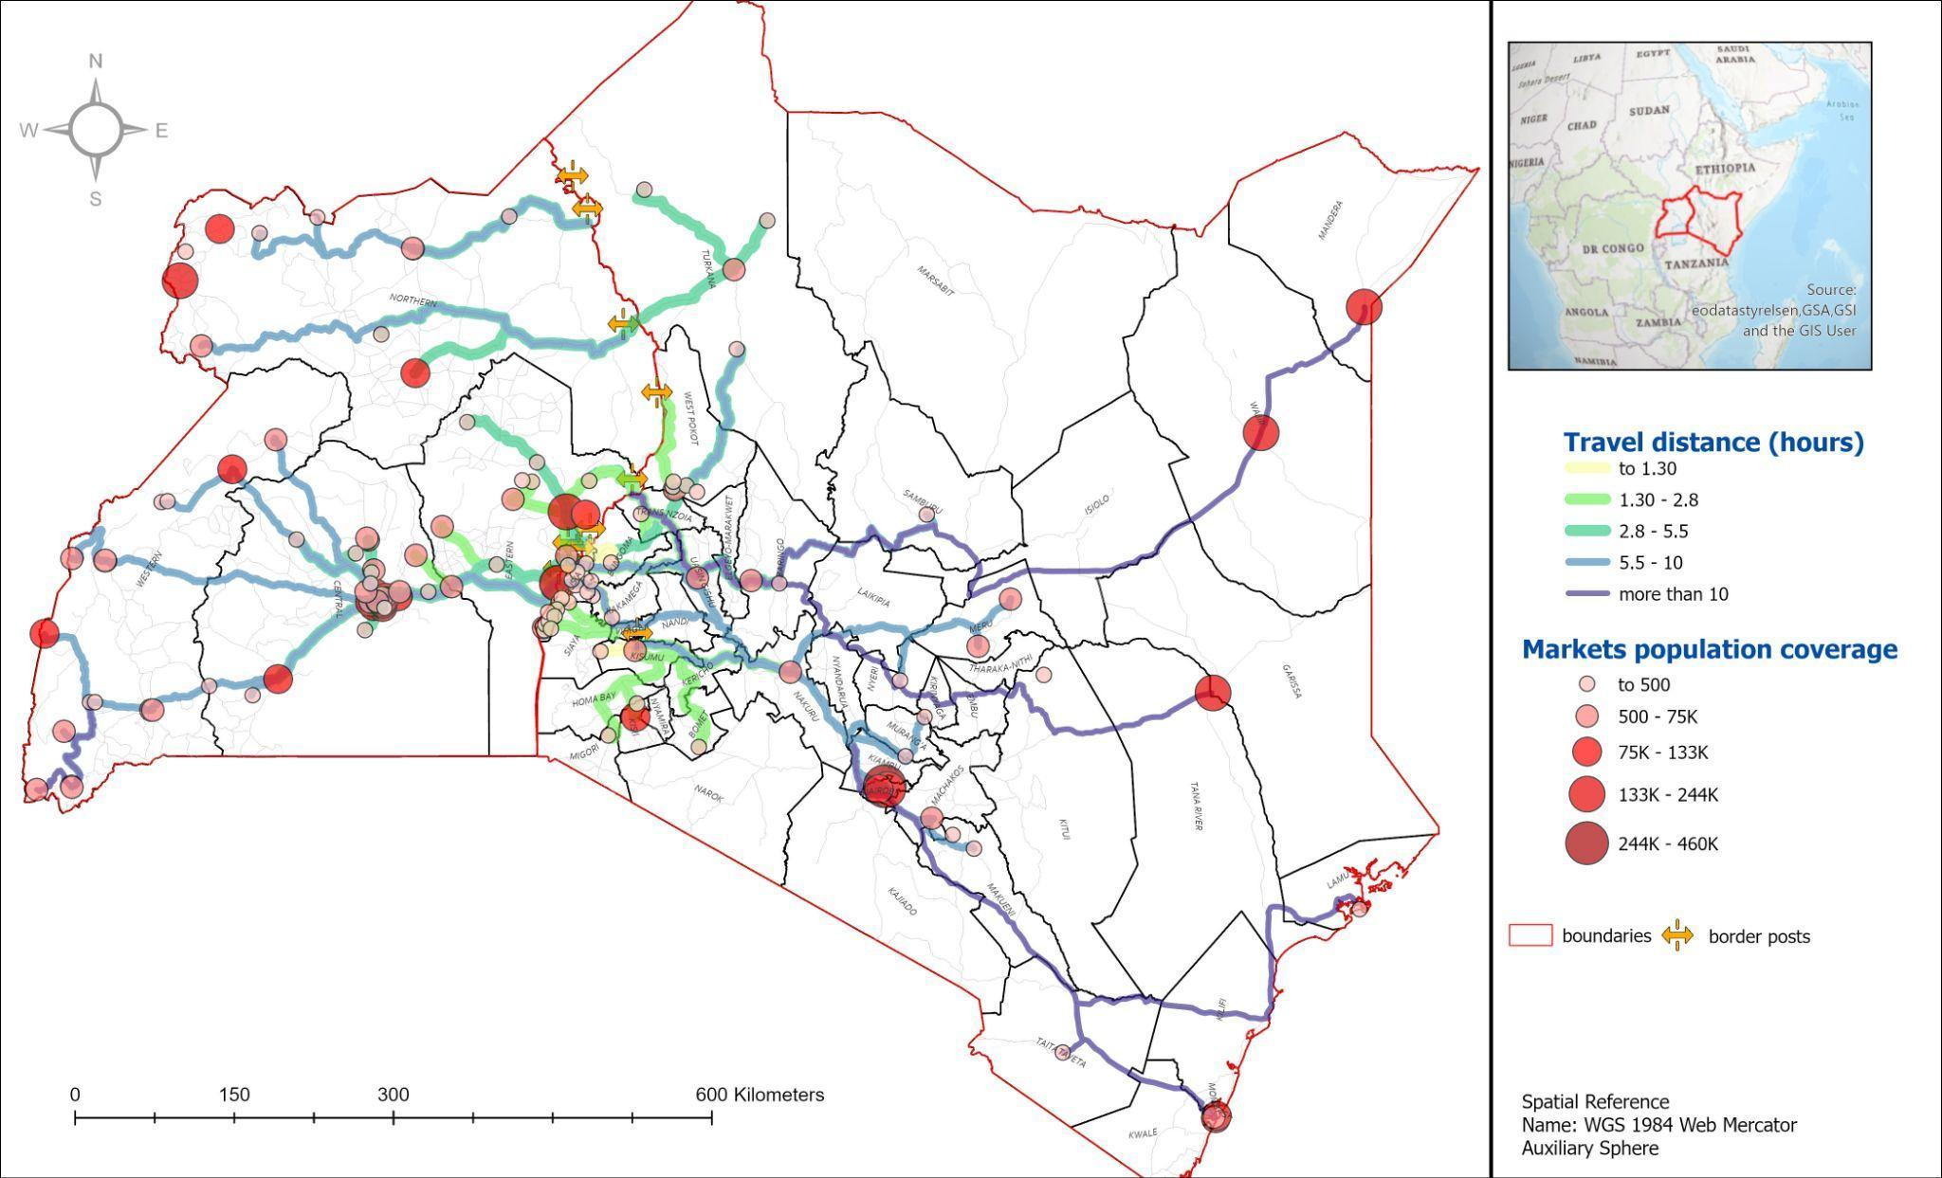

The transportation network analysis relied on OpenStreetMap (OSM) data, which required substantial preprocessing to ensure accuracy. A key step involved cleaning and standardizing the maxspeed attribute, which was incomplete in the raw data. We developed a systematic approach using the Fclass (functional class) of roads to recalculate missing maxspeed values, assigning average speeds based on road type classifications. This cleaned dataset, combined with precise road lengths in meters, enabled accurate calculation of travel times and distances between markets and border points (see map 1).

To be able to move to the statistical calculation step for MPI and CI, we created an integrated dataset that is structured in three main components. The first contains geographic information, linking markets to border points through unique identifiers. This structure accommodates the complex reality of multiple routes between markets and border points, as each market can connect to multiple border posts and vice versa. The second component captures conflict data, including event types and fatality counts. The third component incorporates transportation metrics, specifically route lengths in meters and calculated travel times in minutes.

For analytical efficiency, we developed a simplified version of the route network by selecting the optimal route (based on shortest travel distance) for each market-border pair. However, the master dataset maintains information about multiple route options, reflecting the overlapping nature of trade networks in the region. This approach preserves the complexity of border interactions while enabling focused analysis of primary trade corridors.

Map 2: Market Types and Conflict Fatalities in the Kenya-Uganda Border Region

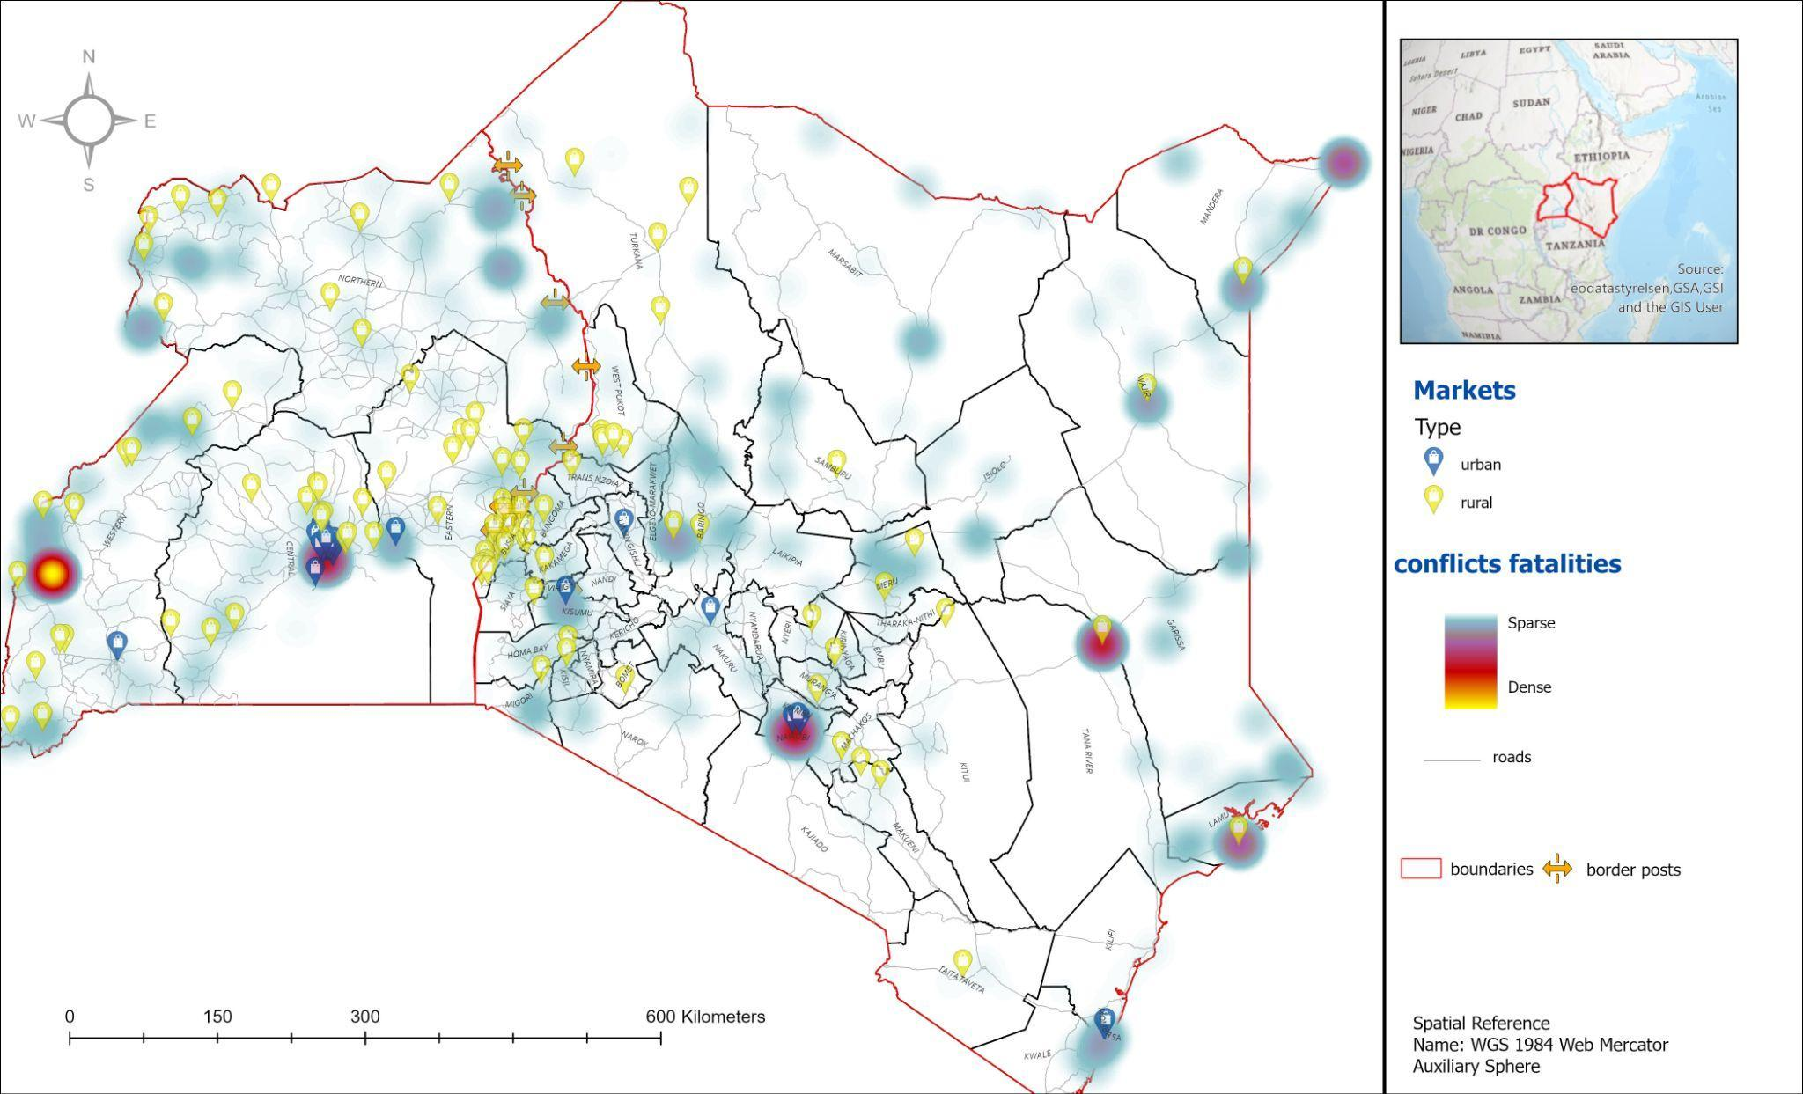

Our validation process included systematic checks of calculated travel times against known journey durations, verification of population assignments through comparison with local demographic data. and ground-truthing of market coverage areas where possible. While our dataset offers comprehensive coverage of the border region, it has certain limitations, such as the inability to fully capture informal trade routes and seasonal variations in market accessibility. These limitations are explicitly acknowledged and addressed in our subsequent analysis and interpretation of results. Overall, this approach allows us to bridge the gap between theoretical understanding and practical analysis.

The results that follow demonstrate how these measurements translate into practical insights about market accessibility, conflict impacts, and regional connectivity. By examining the findings through both the Market Potential Index and Conflict Exposure Index, the discussion illuminates patterns that can inform policy decisions and regional development strategies along the Kenya-Uganda border and potentially other cross-border regions.

## **4. Applying the computational Framework: Insights from the Kenya-Uganda Border**

**Background**

The Kenya-Uganda border is a region characterized by complex social dynamics and recurrent, localized conflicts that do not escalate into large-scale wars but gradually shape the region’s fragility. These conflicts, particularly in Karamoja-Turkana, arise from deep-rooted social and economic tensions, such as cattle rustling, resource competition, and arms proliferation. The persistence of conflicts along the Kenya-Uganda border creates an unstable environment, which significantly impacts cross-border trade patterns (Nakanjako et al., 2021). The northern Uganda–Kenya borderlands is an arid territory with a majority pastoralist population. The people on both sides of the border have the same way of life and a long tradition of collaboration and connection. Distances between settlements are large, the population is scattered, and government services are limited. Herders move their animals in response to the availability of pasture and water under customary governance. Every year, Turkana from Kenya cross the border into Karamoja, Uganda, with tens of thousands of cattle. Yet, the need for mobility has increased with the climate crisis and has become more fraught with worsening insecurity. Herders on both sides argue that they have no choice but to carry arms to protect themselves. They explain that they do not condone breaking laws but seek security (Karamoja–Turkana Community Research Team, 2023).

The southern Uganda-Kenya borderlands are demographically dense, but the variant of peripheral urbanism that has emerged here is one on which border towns have remained relatively small: indeed, the towns in question do not make the top ten in either country. Nevertheless, they have played an important role within regional commercial flows and national governance structures. The three pairing towns -Busia, Malaba and Lwakhakha - share the fact that they are the approved border posts on the southern border between Uganda and Kenya. All the commercial traffic that passes from Kenya through Uganda to Rwanda, South Sudan and the DRC transits through these three towns. The first two are classic examples of 'connected' cities/towns whose fortunes have been transformed by infrastructural investments. The regional integration efforts of the East African Community (EAC) are significantly boosting the importance of border towns. As Customs and Immigration processes are harmonized, major investments are being made in infrastructure, such as new road networks and One-Stop Border Posts (OSBPs). This is notably affecting the twin towns of Busia and Malaba, though in different ways. Busia, in particular, is thriving due to its flat terrain and strategic location, with more business activity on the Kenyan side of the border (Soi & Nugent, 2017).

The Kenya-Uganda border region, from the northern corridors with pastoralist conflicts to the southern posts of Busia and Malaba, provides a context for testing our framework. The contrast between these areas shows why spatial or temporal analysis alone cannot capture border dynamics. While the southern corridor shows how infrastructure and connectivity foster growth, the northern region reveals how conflicts and resource competition create instability.

### **4.1. Layer 1: Spatial Analysis and Market Potential Index (MPI)**

The spatial analysis aims to quantify how infrastructure, distance, and market size influence economic interactions across the Kenya-Uganda border region. This is achieved through the construction and visualization of the Market Potential Index (MPI), a foundational metric rooted in spatial interaction theory (Roy & Thill, 2004). The MPI provides actionable insights into the economic accessibility of border posts, to assess trade potential across regions.

The choice of decay parameters (j=0.02,0.03,0.05) is grounded in established principles of spatial interaction theory and distance decay. These values reflect a range of elasticities, capturing both long-range economic interactions (j=0.02) and localized effects (j=0.05). Previous studies, such as Klaesson et al. (2016), support the use of similar parameter ranges in spatial modeling. For each decay parameter, the MPI values were computed for market-border pairs and aggregated at both the market and border post levels..

The MPI values were visualized using bar charts and heatmaps to highlight differences across borders and decay parameters.. The analysis evaluates the economic potential of markets and border posts along the Kenya-Uganda border, focusing on population, infrastructure, and distance. The findings are contextualized within the spatial interaction theory and interpreted using the results of sensitivity analysis for varying decay parameters (0.02, 0.03, 0.05).

The results consistently highlight the dominance of Busia, Malaba, and Kisumu in terms of MPI across all decay parameters. These border towns benefit from their strategic locations along major transportation corridors, such as the Southern Corridor, and significant infrastructural investments (Chome, 2021). These towns are classic examples of 'connected' cities/towns whose fortunes have been transformed by infrastructural investments. The two towns of Busia are the most lively, benefiting from the flat terrain and favorable location - even if there is surely more business on the Kenya side Tororo and Malaba exhibit MPI values far surpassing other border posts, particularly under the low decay parameter (j = 0.02). Tororo, for instance, achieves the highest MPI value of 0.511 at j = 0.02, reflecting its strategic location and robust infrastructural connectivity. Malaba also maintains a strong economic presence, although it trails behind Tororo. Meanwhile, Kisumu demonstrates moderate regional importance across all decay parameters.

Figure 1: MPI by Border Post

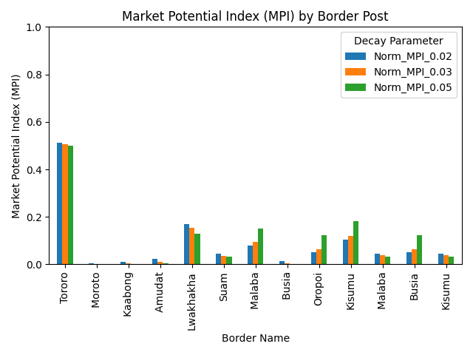

These results align with the understanding that large populations, combined with strong connectivity, amplify the economic potential of these hubs. The findings also underscore the critical role of infrastructure in fostering cross-border economic interactions, as reflected in the spatial clustering patterns.

The heatmaps (Figures 2–4) provide additional insights into how MPI values are distributed spatially across the region. At j = 0.02 (Figure 2), the economic influence of key hubs like Tororo and Malaba extends broadly into surrounding areas, illustrating long-range interactions driven by robust infrastructure and large population centers. This broader spread highlights the capacity of well-connected towns to influence economic dynamics beyond their immediate surroundings.

.

Figure 2: Heatmap for j=0.02

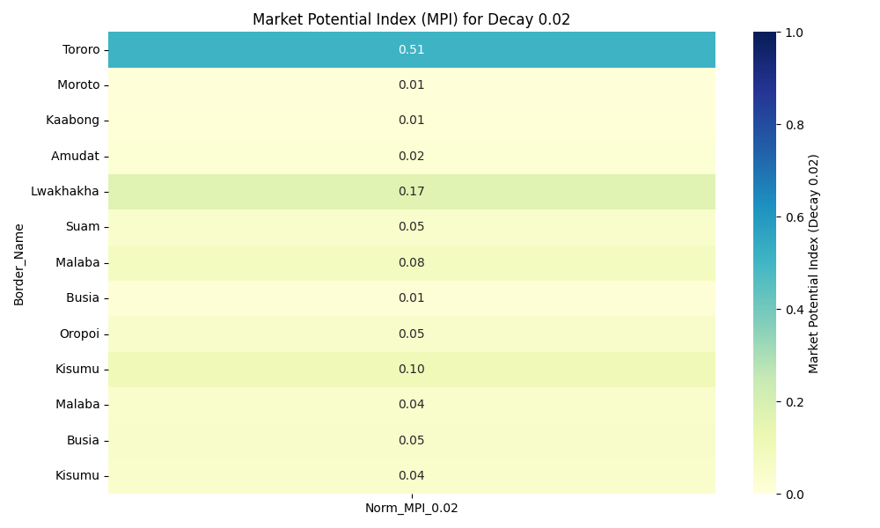

As the decay parameter increases to j = 0.03 and j = 0.05 (Figures 3 and 4), MPI values become more localized. The concentration of economic potential around Tororo, Malaba, and Kisumu becomes even more pronounced, reflecting the reduced influence of distance in shaping economic interactions. This pattern underscores the importance of proximity and infrastructure connectivity, as regions farther from major hubs experience steep declines in MPI values.

Figure 3: Heatmap for j=0.03

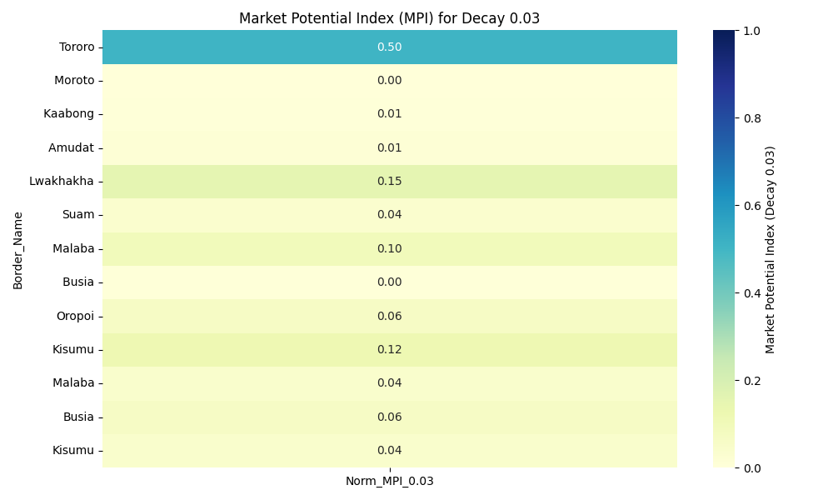

Figure 4: Heatmap for j=0.05

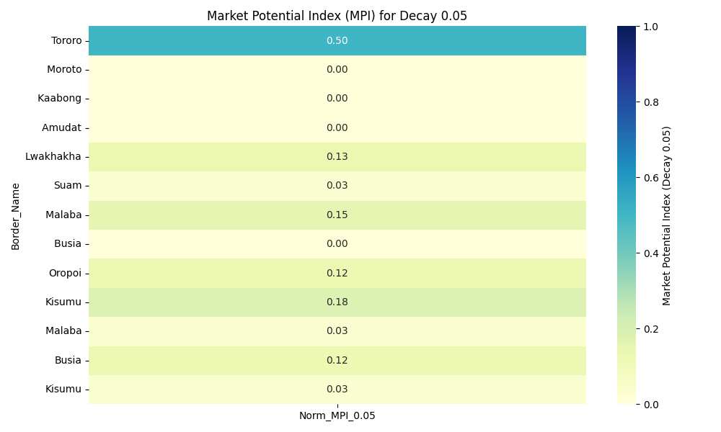

In contrast, smaller and more remote towns like Kaabong, Amudat, and Moroto consistently exhibit the lowest MPI values across all decay parameters. For example, under j = 0.02, Kaabong's MPI remains minimal compared to Tororo's significantly higher MPI. These disparities, visualized in the heatmaps and bar chart, highlight geographic and infrastructural barriers that hinder economic integration in less connected regions. According to Soi & Nugent (2017), poor road networks and inadequate public transportation negatively impact rural livelihoods, limiting trade and economic engagement with other regions.

The localized economic interactions observed at j = 0.05 emphasize the hyper-localized nature of economic activity in areas with limited infrastructure. These findings align with previous research, such as Van Hoestenberghe et al. (2016), which highlights how infrastructure development can mitigate distance-related barriers and promote regional economic integration.

The sensitivity analysis reveals that the choice of decay parameter influences the spatial extent of economic potential. At j = 0.02 (Figure 2), economic hotspots extend beyond major hubs, demonstrating the broader influence of well-connected border towns. In contrast, at j = 0.05 (Figure 4), economic potential becomes concentrated around key hubs like Tororo and Malaba, reflecting the intensified impact of travel costs on economic interactions.

This analysis underscores the importance of understanding distance elasticity when designing infrastructure and trade policies. Policymakers can leverage these insights to strategically allocate resources and prioritize investments that enhance regional integration and economic connectivity.

### **4.2. Layer 2: Conflict Exposure Index (CI)**

The Conflict Exposure Index (CI) quantifies the impact of conflict events on trade routes by integrating temporal, geographic, and conflict-specific variables. This index provides insights into how the frequency and intensity of conflict disrupt economic activity. The analysis applies a mathematical framework that incorporates the severity of conflict events, their proximity to trade routes, and temporal trends to identify regions and periods of heightened instability.

By combining severity and proximity, the CI calculation captures the dual impact of conflict—highlighting areas where trade is most disrupted and periods of heightened instability. This approach aligns with protracted social conflict theory, which emphasizes the compound effects of persistent conflict on economic systems. This layer contributes to understanding the geographic and temporal foundations of conflict-driven trade disruptions in the borderlands. The insights derived from this analysis provide critical context for interpreting the broader trade dynamics, establishing how instability undermines economic activity at critical border points

The results consistently show that Busia and Kisumu experience the highest levels of conflict exposure, as measured by CI. These border posts demonstrate heightened vulnerability due to their strategic importance along major trade corridors and proximity to conflict-prone areas. The temporal analysis of CI reveals periods of heightened conflict exposure and regional instability. (Figure 5) highlights the following patterns. Busia’s exposure peaked in 2020, driven by a surge in conflict events near this key trade hub, due to the population pressure on wetlands availability (Oduma & Apio, 2023). This spike represents a critical disruption in the region’s trade dynamics, with implications for the broader economic system. Kisumu and Malaba demonstrate upward trends in CI, particularly from 2018 onward, reflecting an escalation in regional instability and its impact on these border posts. Border posts such as Kaabong and Amudat show minimal fluctuations in CI values over time, further highlighting their relative insulation from conflict-related disruptions. These findings illustrate how temporal fluctuations in conflict intensity disproportionately affect certain border posts, emphasizing the need for dynamic monitoring and intervention strategies to mitigate trade disruptions.

**Figure 5: Temporal Trends in CI**

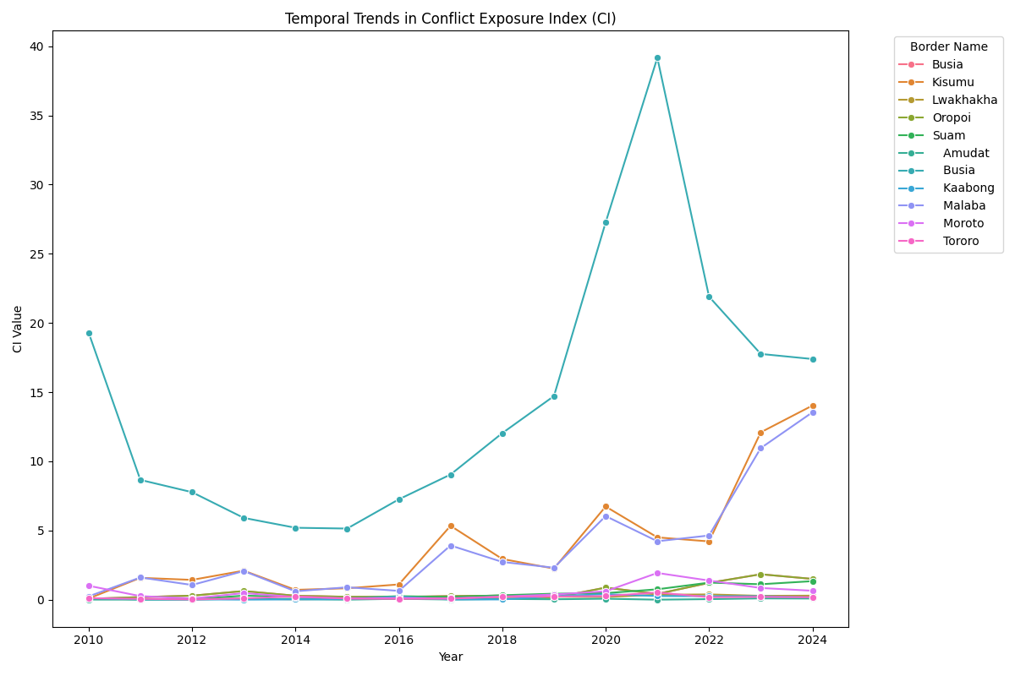

The analysis also underscores stark geographic disparities in conflict exposure. Figure 6 visually emphasizes these differences, with darker shades indicating higher CI values concentrated around key border posts like Busia and Kisumu. In contrast, smaller, more geographically isolated border posts, such as Kaabong and Amudat, exhibit consistently low CI values across all years. For instance, Kaabong’s highest CI value over the entire study period is just 0.40, recorded in 2019.

**Figure 6: CI Heatmap by Border and Year**

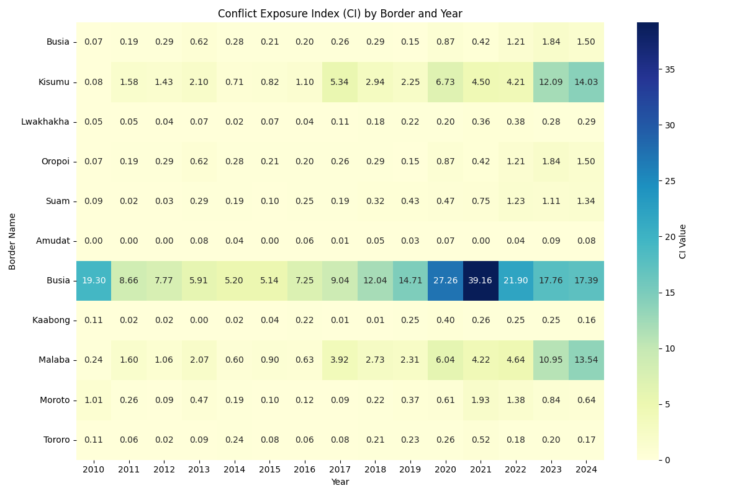 These disparities highlight the protective effect of geographic isolation on conflict exposure. However, they also underscore the limited economic integration of these regions, which reduces their vulnerability to conflict but also constrains their economic potential. This finding aligns with spatial theories that emphasize the role of proximity and connectivity in mediating economic and social impacts.

To be able to test the validity of the Conflict Exposure Index (CI), we constructed a primarily CI using a GIS buffer analysis approach (see map 3). We established a 20 -kilometer buffer zone around each border point to define the relevant area for conflict impact assessment. Within these zones, we identified and weighted conflict events based on two primary factors: the number of fatalities and the proximity to border points.

The CI calculation incorporated binary flags to indicate conflict presence within the buffer zones, with a value of 1, signifying conflict occurrence within the 20 -kilometer radius. The cumulative impact of conflict events was then calculated for each route, creating a weighted measure of conflict exposure in relation to routes around each market. This approach enabled us to identify and visualize routes with varying levels of conflict exposure, with lighter-colored routes indicating higher exposure to conflict events.

**Map 3: Conflict Pressure on Trade Pathways**

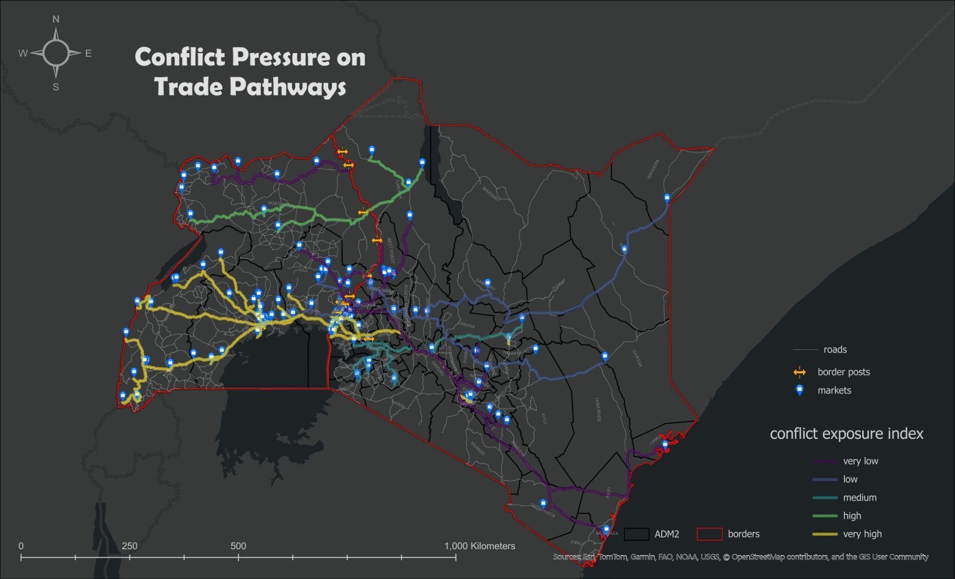

Both the GIS-based and analytical methods highlight Busia and Malaba as the border posts most exposed to conflict. These locations consistently show higher CI values, reflecting their strategic importance along major trade corridors and proximity to conflict-prone areas. Similarly, Kaabong and Amudat exhibit minimal CI values in both approaches, underscoring the protective effect of geographic isolation on conflict exposure. The GIS tools provide enhanced spatial resolution, aligning well with the analytical CI heatmap (Figure 2). Both approaches reveal clustering of high CI values around key trade hubs like Busia, Malaba, and Kisumu, validating the spatial concentration of conflict impacts. While the overall trends align, minor differences in CI magnitudes were observed. For instance, the GIS-based method incorporates precise route lengths and geospatial distances, potentially refining proximity calculations. These adjustments slightly alter CI values but do not change the overall rankings or patterns.

### **4.3. Layer 3: Relational Level**

The relational layer builds on the Market Potential Index (MPI) and Conflict Exposure Index (CI) by integrating ethnic and linguistic data to examine how social and cultural networks intersect with economic and security dynamics. Unlike the spatial focus of the MPI or the temporal-geographic lens of the CI, this layer emphasizes the human dimension of borderlands, recognizing them as zones of interaction shaped by shared histories, cultural connections, and social networks. Drawing on Massey’s (2005) concept of relational space, the analysis overlays geospatially referenced ethnic data with MPI and CI results to explore how cultural networks mediate trade flows and responses to conflict across the Kenya-Uganda borderlands.

The results of this analysis are shown in Map 4 that illustrates the interplay between cultural networks, economic accessibility, and conflict dynamics in the Kenya-Uganda border region. Ethnic boundaries delineated in various colors emphasize the spatial reach of cultural linkages, while MPI gradients depict economic potential across different areas. CI star markers identify conflict hotspots, providing a layered understanding of how these dimensions overlap. This visualization operationalizes the concept of relational space, offering a practical framework to analyze how cultural factors influence both economic resilience and vulnerability to conflict.

Map 4: Relational Dynamics: Ethnic Networks, MPI, and CI in the Kenya-Uganda Borderlands

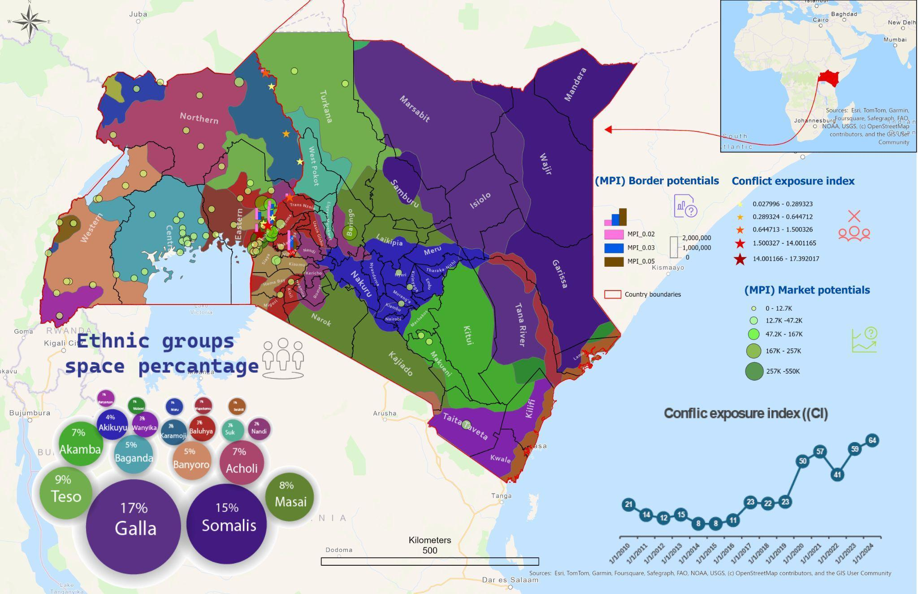

The map reveals that regions with high MPI values, such as Busia, Malaba, and Tororo, overlap with ethnically diverse populations in the southern borderlands. These towns serve as critical economic hubs due to their strategic locations along major transportation corridors and their integration into the cultural networks of the Baganda, Luhya, and Banyoro. Shared linguistic and cultural ties facilitate cross-border trade, reducing transaction costs and enhancing regional integration. For example, the high MPI values in Busia, particularly on the Kenyan side, are attributed not only to infrastructure investments but also to the town’s integration into cultural networks that streamline trade interactions.

Overlaying CI data onto these cultural and economic landscapes reveals additional complexity. Regions such as the Karamoja-Turkana borderlands, which exhibit high CI values (large red star markers), highlight the intersection of cultural and conflict dynamics. In these areas, pastoralist groups like the Turkana and Karamoja face persistent insecurity driven by resource competition, cattle rustling, and arms proliferation. As herders cross borders in search of pasture and water, the risks of violence intensify, exacerbated by the climate crisis (Matiko & Hamasi, 2022). The clustering of high CI markers in this region emphasizes the vulnerabilities of these communities, even as cultural cohesion provides a degree of resilience through customary conflict resolution mechanisms.

The relational analysis underscores the importance of cultural networks in sustaining trade and mitigating conflict in the southern borderlands. Shared linguistic ties among the Baganda, Banyoro, and Luhya underpin the economic vibrancy of towns like Busia and Malaba, where cultural connectivity complements infrastructural investments to drive regional integration. By contrast, the northern borderlands lack similar cultural linkages, due to the harsh ecological conditions that have led to distinct pastoral practices and cultural adaptations (Kareithi, 2015), further entrenching their peripheral status and limiting opportunities for economic advancement.

## **5. Policy Implications and Limitations**

The framework presented in this study provides a computational and quantitative approach to analyzing borderland dynamics. By integrating spatial, temporal, and relational dimensions, it offers policymakers a structured tool to evaluate economic accessibility, conflict risks, and cultural networks. Its application to the Kenya-Uganda border illustrates several critical insights and actionable implications.

High-MPI regions, such as Busia and Malaba, demonstrate significant economic potential due to their strategic locations along the Northern Corridor, robust infrastructure, and large population centers. However, these regions also face high CI values, reflecting persistent conflict exposure that disrupts trade flows and increases vulnerability. For example, Busia’s CI peaked at 39.16 in 2020, highlighting the dual pressures of economic growth and security challenges. These findings underscore the importance of conflict-sensitive infrastructure planning in high-MPI regions, where targeted investments in trade facilities and border security can simultaneously enhance economic integration and mitigate conflict risks (Stewart, 2005).

The analysis also reveals the geographic disparities in economic and security conditions. Remote regions like Kaabong and Amudat exhibit low MPI values due to limited infrastructure and geographic isolation. These regions’ low CI values reflect their relative insulation from conflict zones, but this isolation also perpetuates economic marginalization. Policymakers must carefully balance efforts to integrate these areas into regional economies with strategies to prevent unintended security risks as connectivity increases. Infrastructure development should be complemented by programs that address local vulnerabilities, such as improving access to water and formalizing livestock trade to reduce resource-driven tensions (Sharamo, 2014).

The relational layer further illustrates the role of social networks in mitigating conflict impacts and sustaining trade. Shared linguistic ties among the Baganda, Banyoro, and Luhya populations in the southern borderlands enhance cross-border economic activity, as cultural cohesion reduces transaction costs and facilitates trade. In contrast, the northern borderlands lack similar cultural linkages, exacerbating their economic isolation despite the resilience offered by ethnic networks like the Turkana and Karamoja. These findings suggest that policymakers could strengthen cultural and economic connectivity by promoting cross-border trade associations and community-based initiatives that build on existing cultural ties (Massey, 2005).

Despite its contributions, the framework has limitations. Its reliance on datasets such as GREG and ACLED introduces potential biases. GREG’s ethnic boundaries are derived from historical maps, which may not fully reflect contemporary population distributions (Weidmann et al., 2010), while ACLED data underreport low-intensity conflicts or informal violence (Raleigh et al., 2010) These data gaps can affect the precision of relational and temporal analyses. Additionally, the MPI currently lacks a temporal dimension, limiting its ability to link trade patterns directly to conflict exposure over time. Incorporating trade data into the analysis would allow the framework to detect more dynamic relationships between economic activity and conflict.

The computational nature of the framework also presents challenges. Its reliance on GIS tools and parameterized models requires technical expertise and computational resources, which may not be accessible to all policymakers. Further simplifying the framework through user-friendly tools or automated dashboards could enhance its usability at the local level. Additionally, while the framework captures existing dynamics, its lack of predictive capabilities limits its ability to anticipate future challenges, such as climate-driven migration or emerging conflict risks. Machine learning algorithms could enhance the framework’s forecasting potential, offering more proactive insights for policymakers.

## **6. Conclusion**

This study introduces a computational framework for analyzing borderland dynamics, integrating spatial (MPI), temporal (CI), and relational layers to provide a comprehensive understanding of economic, conflict, and cultural factors. Its application to the Kenya-Uganda border highlights the value of this approach in supporting evidence-based policymaking and addressing the complexities of borderland development.

The findings reveal that high-MPI regions like Busia and Malaba, while economically significant, are vulnerable to conflict disruptions, necessitating conflict-sensitive infrastructure planning. Conversely, regions like Kaabong and Amudat remain economically marginalized due to limited connectivity, despite their relative stability. The relational layer emphasizes the resilience of cultural networks, particularly in regions with strong linguistic and ethnic cohesion, where cultural ties facilitate trade and mitigate conflict risks. These insights underscore the need for policies that balance infrastructure investment, security planning, and cultural connectivity.

To ensure the reproducibility and transparency of this framework, a [Git repository](https://github.com/monyas96/Computational-Framework-for-Borderland-Analysis) has been established, containing detailed documentation, scripts, and sample datasets used in the analysis. This repository allows researchers and policymakers to replicate the analysis, adapt the framework to other border regions, or integrate additional datasets. By providing open access to the methodological components, the repository promotes collaboration and encourages further refinement of the framework.

In conclusion, this study establishes a foundation for systematic border analysis, offering policymakers a tool to transform fragmented data into actionable insights. Its computational design ensures scalability and replicability, making it applicable across diverse border contexts. By enabling policymakers to evaluate trade-offs and prioritize investments with precision, the framework contributes to a deeper understanding of borderland dynamics and provides a pathway to sustainable, evidence-based interventions that bridge local and regional development priorities.

## **6. Bibliography**

*Azar, E. E. (1990). The management of protracted social. London, UK: Dartmouth Publishing Company.*

*Africa, T. E. (2014). One stop border posts–contributing to the ease of doing business in East Africa. Resources: Impact Stories, 20.*

*Chome, N. (2021). Borderland Infrastructure and Livelihoods.*

*Cuellar, G. L. (2015). Book review: Borders: A Very Short Introduction, written by Alexander C. Diener and Joshua Hagen. Horizons in Biblical Theology, 37(1), 93-95.*

*Eberhard-Ruiz, A. (2024). The Impact of Armed Conflict Shocks on Local Cross-Border Trade: Evidence from the Border between Uganda and the Democratic Republic of Congo. Economic Development and Cultural Change, 72(3), 1151-1187.*

*Fotheringham, A. S. (1982). Distance-decay parameters: a reply.*

*Johansson, B., & Klaesson, J. (2017). Distance decay for supply and demand potentials. Letters in spatial and resource sciences, 10, 87-108.*

*Kareithi, J. N. (2015). The Multi-factoral Nature of Inter-Ethnic Conflicts in North-Rift Frontier Border Lands, Kenya: Implications on Pastoralists welfare and Livelihoods. Journal of anthropology and archaeology, 3(1), 37-57.*

*Krugman, P. (1998). What's new about the new economic geography?. Oxford review of economic policy, 14(2), 7-17.*

[*https://doi.org/10.19088/sshap.2022.043*](https://doi.org/10.19088/sshap.2022.043)

*Karamoja–Turkana Community Research Team. (2023). Community Solutions to Insecurity Along the Uganda–Kenya Border [Report]. The Institute of Development Studies and Partner Organisations. https://doi.org/10.19088/IDS.2023.057']*

*Kawakubo, F. (2015). A Critical Development of Border Studies. J. Territorial & Mar. Stud., 2, 137.*

*Kolossov, V., & Scott, J. (2013). Selected conceptual issues in border studies. Belgeo, 1. https://doi.org/10.4000/belgeo.10532*

*Lamarque, H., & Brown, H. (2022). Key Considerations: Cross-Border Dynamics Between Uganda and Kenya in the Context of the Outbreak of Ebola, 2022.*

*Matiko, C. N., & Hamasi, L. (2022). Community-Based Strategies Of Controlling Small Arms And Light Weapons Proliferation In West Pokot County, Kenya. Journal of African Interdisciplinary Studies, 6(10), 34-48.*

*Massey, D. (2005). The spatial construction of youth cultures. In Cool places (pp. 132-140). Routledge.*

[*https://doi.org/10.1353/eas.2021.0005*](https://doi.org/10.1353/eas.2021.0005)

*Ndalilah, J. W., & Atozo, Z. O. (2024). The Impact of Informal Cross-Border Trade on Kenya-Uganda Foreign Relations.*

*Odhiambo, E. C., Losenje, T., & Indede, F. (2022). Kiswahili as an Intercultural Communication Tool for Kenya-Uganda Cross-border Trade. Journal of Humanities and Social Sciences Studies, 4(3), 67-112.*

*Oduma, P., & Apio, R. (2023, August 3). When the Boundary Moves: A Hidden Dispute on Kenya-Uganda Border. Life & Peace Institute. https://life-peace.org/blog/when-the-boundary-moves-a-hidden-dispute-on-kenya-uganda-border/*

*Perkmann, M., & Sum, N. L. (2002). Globalization, regionalization and cross-border regions: scales, discourses and governance. In Globalization, regionalization and cross-border regions (pp. 3-21). London: Palgrave Macmillan UK.*

*Roy, J. R., & Thill, J. C. (2004). Spatial interaction modelling. Papers in Regional Science, 83(1), 339-361.*

[*https://doi.org/10.1080/08865655.2016.1196601*](https://doi.org/10.1080/08865655.2016.1196601)

*Nakanjako, R., Kabumbuli, R., & Onyango, E. O. (2021). Positioning Migrants in Informal Cross Border Trade: The Case of Busia, Uganda-Kenya Border. Eastern Africa Social Science Research Review, 37. https://doi.org/10.1353/eas.2021.0005*

*Raleigh, C., Linke, R., Hegre, H., & Karlsen, J. (2010). Introducing ACLED: An Armed Conflict Location and Event Dataset. Journal of Peace Research, 47(5), 651–660.* [*https://doi.org/10.1177/0022343310378914*](https://doi.org/10.1177/0022343310378914)

*Rodrigue, J. P. (2016). The role of transport and communication infrastructure in realising development outcomes. The palgrave handbook of international development, 595-614.*

*Sharamo, R. (2014). The politics of pastoral violence: a case study of Isiolo County, northern Kenya.*

*Soi, I., & Nugent, P. (2017). Peripheral Urbanism in Africa: Border Towns and Twin Towns in Africa. Journal of Borderlands Studies, 32(4), 535–556.* [*https://doi.org/10.1080/08865655.2016.1196601*](https://doi.org/10.1080/08865655.2016.1196601)

*Stewart, F. (2005). Horizontal Inequalities: A Neglected Dimension of Development. In UNU-WIDER, A. B. Atkinson, K. Basu, J. N. Bhagwati, D. C. North, D. Rodrik, F. Stewart, J. E. Stiglitz, & J. G. Williamson, Wider Perspectives on Global Development (pp. 101–135). Palgrave Macmillan UK. https://doi.org/10.1057/9780230501850_5*

*Storper, M. (1997). The regional world: Territorial development in a global economy. Guilford Press.*

*Van Hoestenberghe, K., Roelfsema, H., & Khalidi, S. (2016). The making of the East African Community: A case study. In The EU and World Regionalism (pp. 235-250). Routledge.*

*Weidmann, N. B., Rød, J. K., & Cederman, L.-E. (2010). Representing ethnic groups in space: A new dataset. Journal of Peace Research, 47, 491–499.* [*https://doi.org/10.1177/0022343310368352*](https://doi.org/10.1177/0022343310368352)

*Weidmann, N. B., Rød, J. K., & Cederman, L. E. (2010). Representing ethnic groups in space: A new dataset. Journal of Peace Research, 47(4), 491-499.*